**Employee Manager System**

1. Dashboard

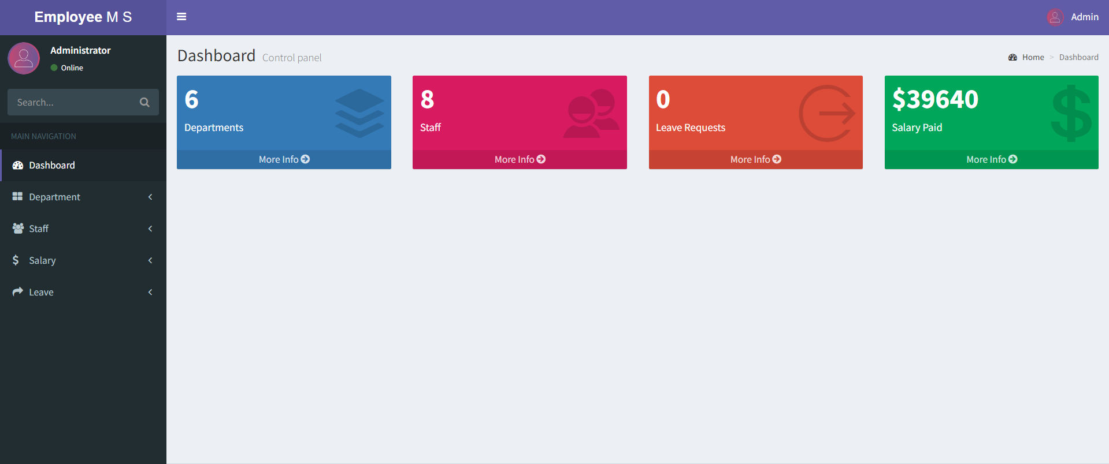

1. Login Page

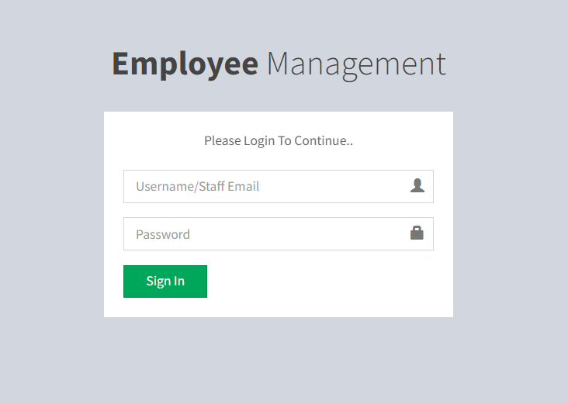

1. Manage Staff Page

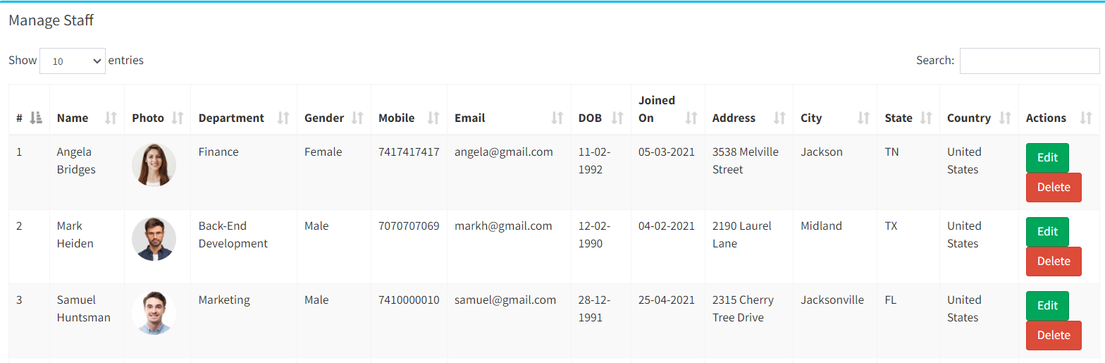

1. Manage Departments Page

